Implementation Guide
Define Your Test Policies and Procedures

Where people meet potential

Contents

Online Proctoring Business Rules 3
Admission Process / ID Verification 5
Appendix A: Establish Proctoring Violations And Severities 7
Appendix B: Online Proctor Standard Scripting 12

This procedural document includes general business rules and admission processes and procedures, along with scripting.
These guidelines are to be utilized as the standard for all PSI global proctor instruction guides, which can be modified based on client preference/need.

Online Proctoring Business Rules

Use this interactive form to set your test rules
Client Name | …

Exam Name | Acronym | Duration (mins)
… | … | …
… | … | …
… | … | …
… | … | …
Will test takers see their pass/fail information on screen at the end of
the assessment?
☐ | No |  | ☐ |  | Yes
What is the number of ID’s required? (Standard for online proctoring is one)
Choose an item.
Will test takers be allowed to take breaks?
☐ | No |  | ☐ |  | Yes
If yes, how long will the test taker be allowed to leave?
Click or tap here to enter text.
Does your test have scheduled breaks? (e.g. associated with a break in test sections) and/or will your test takers be allowed to take unscheduled breaks (i.e. at the test taker’s request, on demand)?
☐ | Scheduled |  |  |  |  |  | ☐ | Unscheduled
Will test takers be allowed to have reference materials?
☐ | No |  | ☐ |  | Yes
If yes, what materials are allowed?
Click or tap here to enter text.
Will test takers be allowed to use scratch paper?
☐ | No |  | ☐ |  | Yes
If yes, how many sheets of papers? |  |  |  |  |  |  |  |  | Choose an item.
Will test takers be allowed to use their personal calculators?
☐ | No |  | ☐ |  | Yes
If yes, please describe any restrictions (non-programmable / other (e.g. graphing))
Click or tap here to enter text.
Will test takers be allowed to use a whiteboard?
☐ | No |  | ☐ |  | Yes
Will test takers be allowed to drink water? (not as an accommodation)
☐ | No |  | ☐ |  | Yes
If yes please describe any restrictions (e.g., clear bottle/glass only).
Click or tap here to enter text.
Will test takers be allowed to eat food? (not as an accommodation)
☐ | No |  | ☐ |  | Yes
If yes, please describe any restrictions (e.g., no wrappers).
Click or tap here to enter text.
Other personal items (e.g. medications, masks)
☐ |  | No |  | ☐ |  | Yes
If yes, what items are allowed?
Click or tap here to enter text.

Exceptions
Please review the guidelines below and ensure that you specify test taker allowances and accommodations.
Please include any accommodations outside of the online proctoring rules that are listed, such as the use of screen readers, extra time allowances, parent/guardian assistance, the use of temporary ID’s etc.
Other special accommodations allowed and/or not allowed:
 | a) | Click or tap here to enter text.
 | b) | Click or tap here to enter text.
 | c) | Click or tap here to enter text.
 | d) | Click or tap here to enter text.
 | e) | Click or tap here to enter text.

Admission Process / ID Verification
This section will provide details regarding acceptable test taker identification.
Important: Test takers must register for the test using their LEGAL first and last name as it appears on their government issued identification.
All required identification below must match the first and last name under which the test taker is registered.

Accepted name discrepancies (if allowed):
- Click or tap here to enter text.
- Click or tap here to enter text.
- Click or tap here to enter text.

Please note standard practice is that only one form of valid identification is needed when a test taker is taking an online proctored test.
If the test taker fails to bring proper identification or the test taker names do not match, the test taker will not be allowed to test, and their test fee will not be refunded.
Primary identification
(Choose those that apply)
All applicants (Required) |  |  | Primary ID (Required)
Must be: |  |  | Government issued:
☐ | Current and valid (not expired) |  | ☐ | Driver’s License
Must include: |  |  | ☐ | Identification card
☐ | Photo |  | ☐ | Passport
☐ | Date of birth |  | ☐ | Residency card
☐ | Physical residential address
☐ | Signature
Other criteria:
☐ | Admission photos MUST be taken prior to the session
☐ | Verify clear capture from the computer camera
☐ | Photo on ID must match the test taker

PSI Internal Tech Support Hotline
Inside the U.S. (844) 267-1017 | Outside the U.S. 1-617-564-9052**
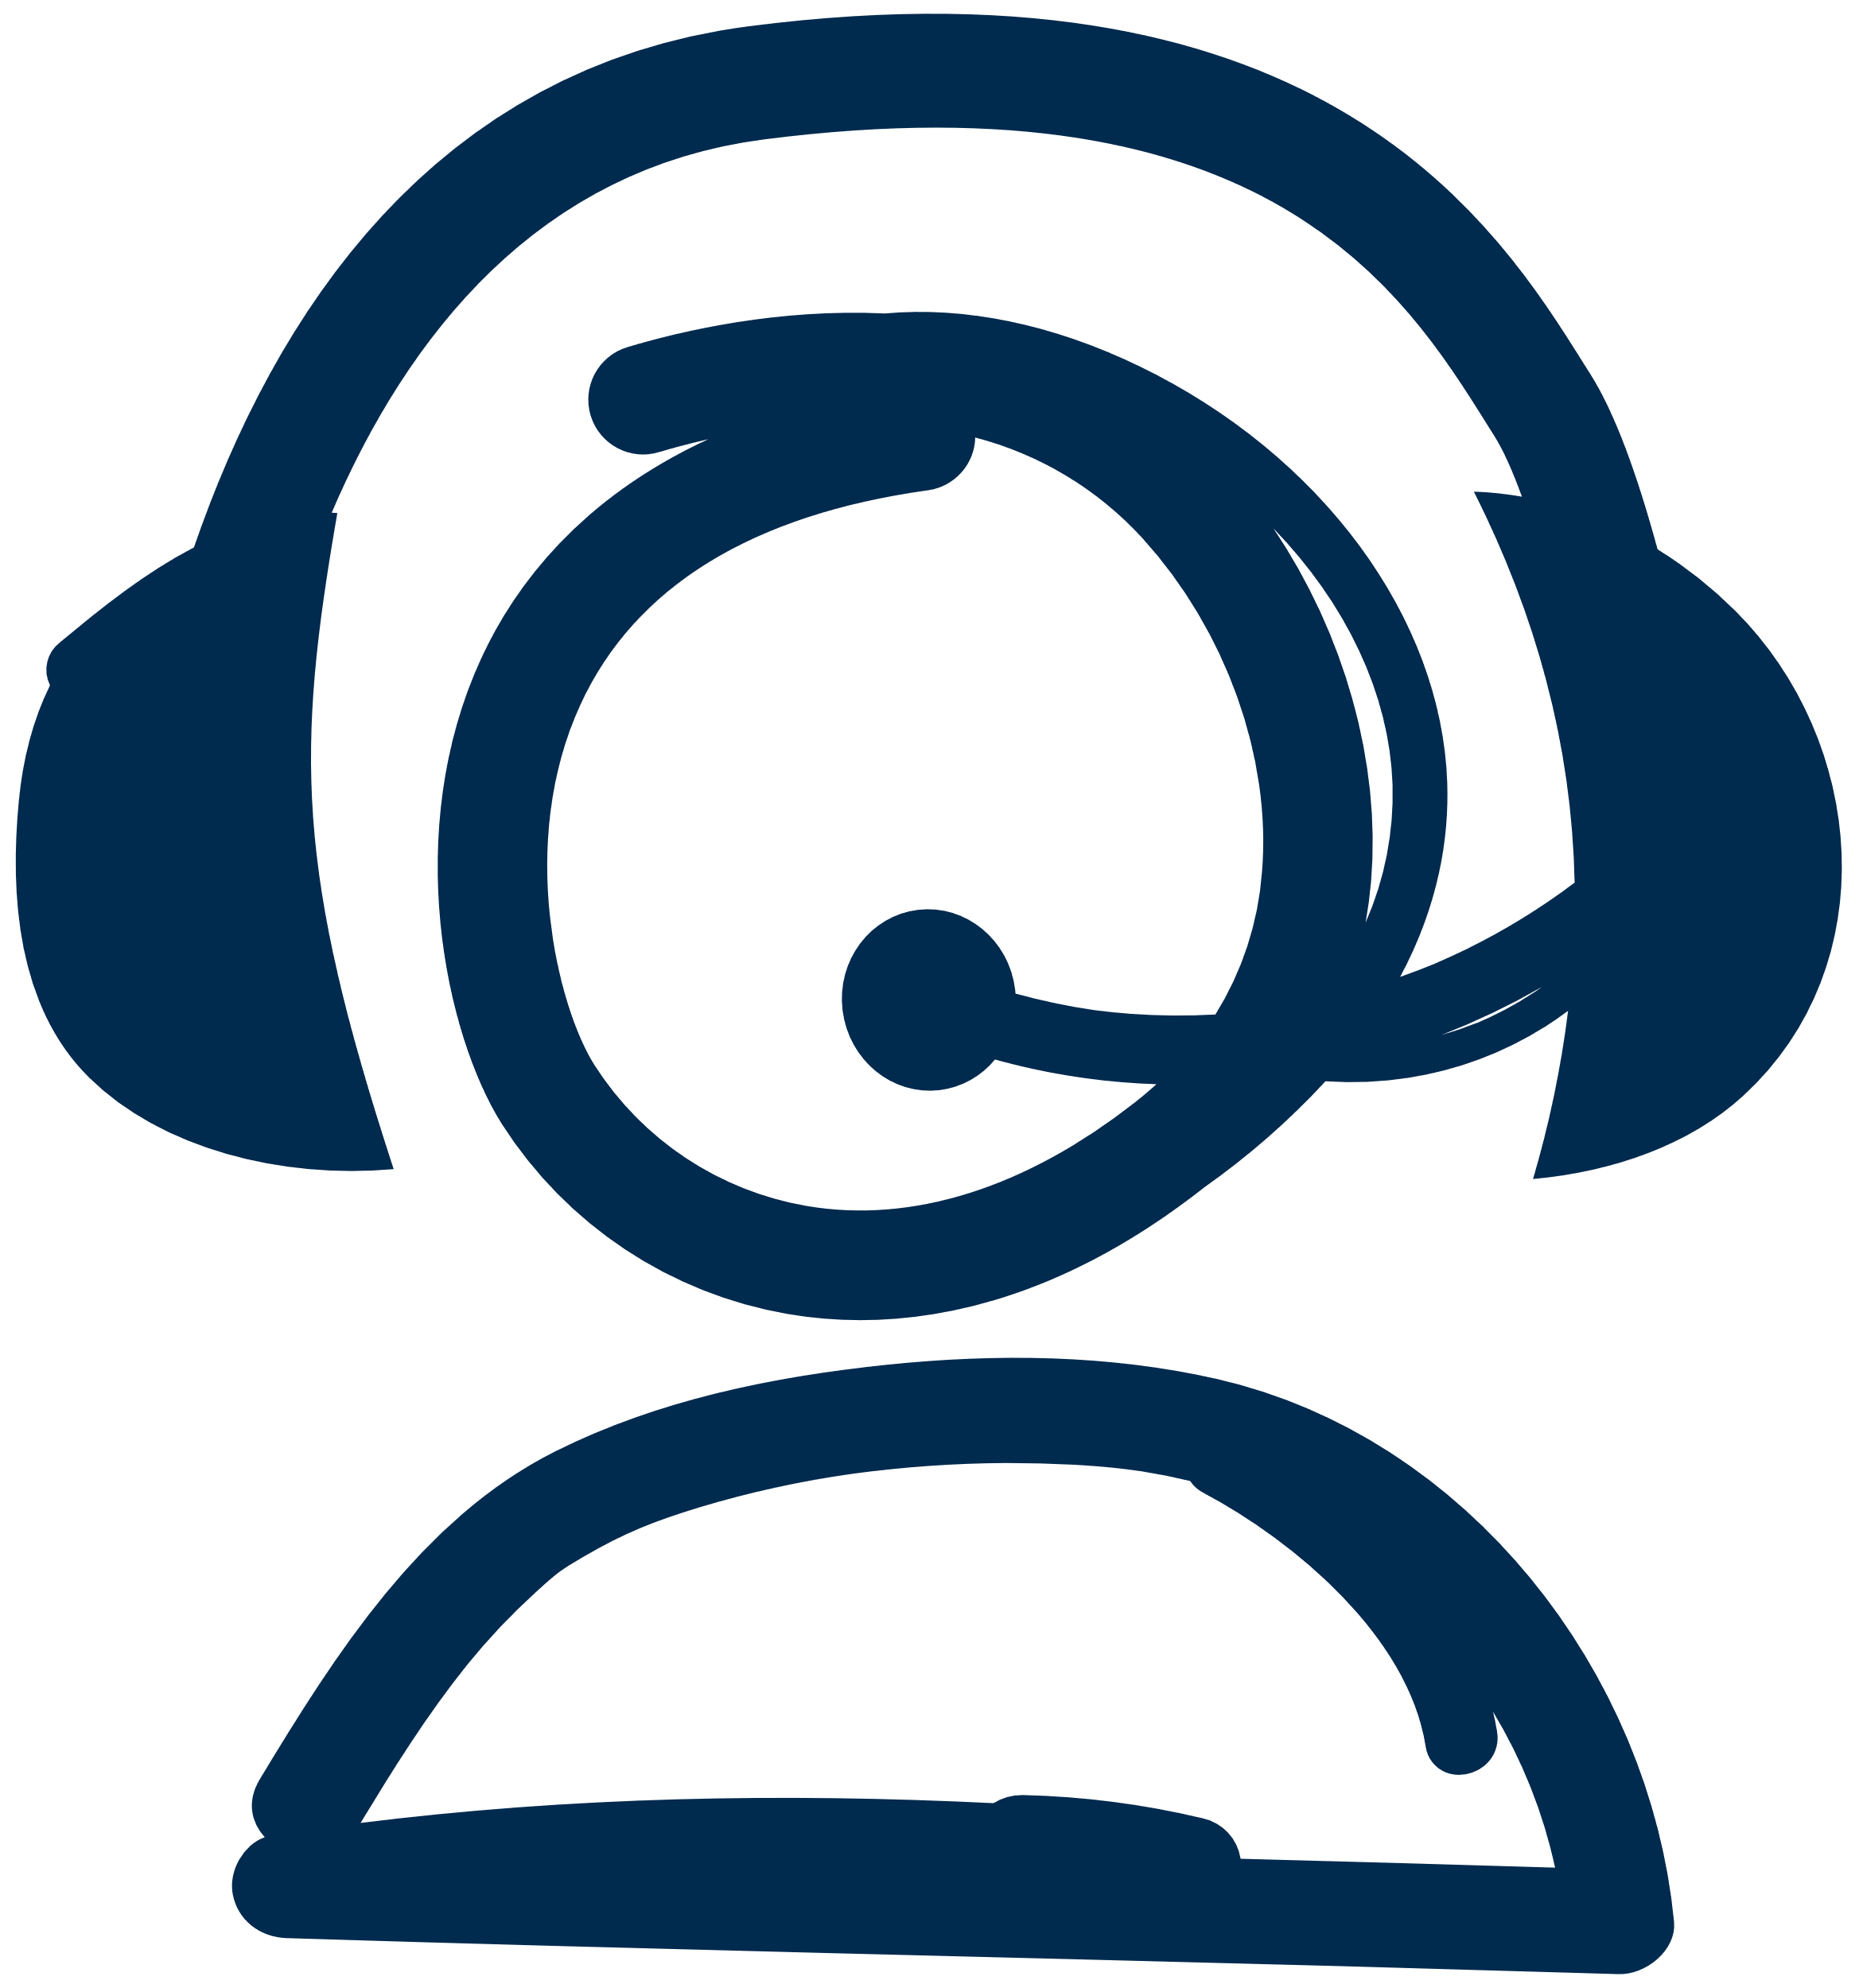
**International call charges might apply if you are calling outside the United States.
Online Chat
http://clientportal.softwaresecure.com/support/

Check-in process
PSI Bridge™ guides the test taker through the check-in process, completing the compatibility check and the security checks, then submitting for proctor approval:
- Valid and current (not expired), government-issued, photo identification
- Selfie picture (to compare with the photo id)
- Webcam scan of the room and workspace

After check-in items are accepted by the proctor, the “Chat with Proctor” button becomes active, test taker reads and accepts onscreen Terms and Conditions and the Admission Rules page

Appendix A: Establish Proctoring Violations
And Severities
Minor violations – between 1 and 3 flagged warnings for a minor violation may occur before the test is terminated, as determined by the Client/Sponsor.
Major Violations – only 1 flag will occur for a major violation before the test is terminated. An on-screen message will advise the test taker which rule was violated and that the test will be terminated. The Proctor will file an incident report and direct the test taker to the Client/Sponsor for any questions.
Rule # | Category | Proctoring rule name | Proctoring rule category | Severity | Warnings allowed (minor only: 1-3) | What does this mean?
1 | Webcam | Talking to someone else in room | Someone else in the room | Minor | 2 | Someone other than the candidate in the room during the session and candidate speaks to that person
2 | Webcam | Someone else in the room / seeking exam help | Exam behavior/someone else in the room | Major | 0 | Someone other than the candidate in the room during the session and candidate asks for assistance on the exam
4 | Webcam | Environment changes | Environment | Minor | 2 | Candidate changes spaces during the exam
6 | Webcam | Improper lighting | Environment | Minor | 2 | Lighting is inadequate or too strong for the proctor to see
8 | Webcam | Failed to erase/clean the whiteboard writing | Environment | Major | 0 | Candidate did not wipe whiteboard at exam's conclusion
9 | Webcam | Improper device placement | Environment | Minor | 2 | Candidate camera is not placed for ideal viewing by the proctor
10 | Webcam | Chewing gum or eating/drinking | Exam behavior/candidate is consuming or displaying food or drink | Minor | 2 | Candidate is eat, drinking, or chewing gum during exam
11 | Webcam | Explicit behavior | Exam behavior/explicit | Major | 0 | Candidate is acting in an inappropriate manner
12 | Desktop | Explicit materials | Exam behavior/explicit | Major | 0 | Candidate has inappropriate materials in view of the desktop
13 | Webcam | Covering the camera | Exam behavior/out of view of the camera | Major | 0 | Candidate places an object over the camera to obstruct the proctor's view
14 | Webcam | Out of view of camera | Exam behavior/out of view | Minor | 2 | Candidate moves temporarily out of the camera's line of sight
15 | Webcam | Failed to show allowed materials | Materials (allowed) | Major | 0 | Candidate not show reference materials to the proctor
16 | Webcam | Failed to rip allowed materials | Materials (allowed) | Major | 0 | Candidate did not destroy reference material
17 | Webcam | Flipping of the pages | Exam content/candidate is coping content in some way | Minor | 2 | Candidate continuously flips pages of reference material
18 | Desktop | Browsing other websites | Exam behavior/browsing | Major | 0 | Candidate is browsing the internet
19 | Desktop | Browsing local computer | Exam behavior/browsing | Major | 0 | Candidate is browsing other local resources during the exam
20 | Webcam | Copy exam content in paper/written | Exam content/candidate is coping content in some way | Major | 0 | Candidate writes down exam content
21 | Desktop | Screen recording software copies exam content | Materials (not allowed) | Major | 0 | Candidate has a smartwatch visible in the testing area
22 | Webcam | Copy/paste content + saves to computer | Exam content/candidate is coping content in some way | Major | 0 | Candidate performs a copy/paste of exam content and saves content
23 | Webcam | Takes picture or video of the screen | Exam content | Major | 0 | Candidate takes a picture or video of the screen
24 | Webcam | Tapping feet or fingers | Exam behavior/candidate is causing noise unrelated to keyboard typing | Minor | 2 | Candidate is causing noise unrelated to keyboard typing
25 | Webcam | Talking aloud/talking to yourself | Exam behavior/candidate is causing noise unrelated to keyboard typing | Minor | 2 | Candidate is speaking aloud but not to someone else
26 | Webcam | Explicit language | Exam behavior/explicit | Major | 0 | Candidate is using abusive language out loud or via the chat
27 | Webcam | Reading questions aloud | Exam behavior/candidate is reading questions aloud | Ignore | 0 | Candidate is reading the questions out loud
28 | Desktop | Other application | Outside resources | Major | 0 | Candidate is using "other" application on their computer
29 | Desktop | Open calculator | Outside resources | Major | 0 | Candidate is using a calculator on their computer
30 | Desktop | Open notepad | Outside resources | Major | 0 | Candidate is using notepad on their computer
31 | Desktop | Open instant messaging | Outside resources | Major | 0 | Candidate is using instant messaging on their computer
32 | Webcam | Looking somewhere else | Exam behavior/looking somewhere else | Minor | 2 | Candidate is not focusing eyes on the screen
33 | Webcam | Left room | Exam behavior/left room | Major | 0 | Candidate left the room (with or without informing the proctor)
35 | Webcam | Reference materials | Exam behavior/candidate is causing noise unrelated to keyboard typing | Minor | 2 | Candidate is using reference materials when they are not allowed (including scratch paper)
36 | Desktop | System error | Technical problem | Minor | 2 | Candidate experiences a system error
37 | Desktop | Lost internet connection | Technical problem | Minor | 2 | Candidate's internet service is interrupted
45 | Webcam | Earbuds present | Electronic/device present in room | Minor | 2 | Candidate has earbuds visible in the testing area
46 | Webcam | Another computer present (not in use) | Electronic/device present in room | Ignore | 0 | Candidate has another computer visible in the testing area
47 | Webcam | Radio is present | Electronic/ device present in room | Minor | 2 | Candidate has a radio visible in the testing area
48 | Webcam | Smartwatch is present (not in use) | Electronic/device present in room | Ignore | 0 | Candidate has a smartwatch visible in the testing area
49 | Webcam | Mobile device present (not in use) | Electronic/device present in room | Ignore | 0 | Candidate has a mobile device visible in the testing area
50 | Webcam | Handheld calculator | Outside resources | Major | 0 | Candidate is attempting to use a handheld calculator when it's not allowed
51 | Webcam | Tv is present | Electronic/device present in room | Ignore | 0 | Candidate has a tv visible in the testing area
52 | Webcam | Headset present | Electronic/device present in room | Ignore | 0 | Candidate has headset or earbuds visible in the testing area
53 | Webcam | Using mobile device/telephone | Electronics/use of electronics during exams | Major | 0 | Candidate attempts to use a telephone or mobile device
54 | Webcam | Using another computer | Electronics/use of electronics during exams | Major | 0 | Candidate attempts to use another computer

Appendix B: Online Proctor Standard Scripting
Scripting to be used by the online proctor to inform test takers before they take their test. PSI online proctors use one standard script for all clients
Send welcome message -- Please keep in mind, test takers may be very nervous and have various levels of test taking anxiety.
You can help put them at ease with your voice [tone/pitch], by exercising patience and even correctly spelling messages in the chat box helps.
And always... let test taker hear the smile in your voice!
“Hello! I will be your proctor today.”

Opening welcome statement/script
Hello! I will be your live proctor for this test today. Please be aware your test timer does not begin until the admission process is complete, and I have released your test. If you have questions before or during the test, you can use the chat feature and I will be glad to assist you with any concerns not related to the content of your test.

Optional scripting
(Use only as needed)
Copy/paste scripts are highlighted with a dotted border.
[Only if allowed]
You are allowed to use either a dry erase board or two (2) sheets of scratch paper for this exam. Would you please show both the front and back of the noteboard or paper to the camera. Thank You!

[Only if allowed]
You are allowed to use a pencil and paper for this exam. Would you please show both the front and back of the paper to the camera. hank You!

[Only if allowed]
You are allowed to have a glass of water or water bottle without any label. If you have either of these, please show me. Thank You!

[Only if allowed]
You are allowed to use reference books/materials. Please hold up each book to the webcam and flip through the pages to show there are no loose papers or sticky notes in the book. Handwritten notes already in the book are allowed, however, no writing in the book is allowed during the exam.
Religious headwear (if worn by the test taker)

Will you please, kindly confirm your headwear is worn for religious purposes?
Wait for response then send the follow-up script:
Thank You! You do not need to remove it, but please keep it on for the duration of the exam.

Last message
If you encounter an issue with your test and you are not able to chat with me, please put both hands up to the camera above the monitor to make me aware that there is an issue.
You can also exit the browser and reconnect immediately to continue the session. If you are still unable to log back into your test, you may reach out to the Technical Helpdesk team at: (844) 267-1017, or to chat at: http://clientportal.softwaresecure.com/support/

You are now ready to…
Release the test
Last message to send – after you release the test:
Thank you and we wish you a successful test! You may close the chat and begin your test. If you need to contact me, please click the “Chat with Proctor” option in the test toolbar.

Exam completion
Your exam is now complete! You are not allowed to take a picture or print the confirmation page. Once you are done reading the results page, please let me know so I can close the exam.

Wait for Response - Send the follow-up script:

You will receive an email notification from the Exam Sponsor that will include further instructions regarding test scores and/or next steps.

Optional Script – Use Only if Item was Allowed
Will you please rip/tear up the used scratch paper in front of the webcam.
Thank You!

Will you please clear/wipe off the dry erase board in front of the webcam.
Thank You!

Final message

I will now mark your session as complete. Thank you for testing with PSI.
Have a nice day!

© 2021 PSI Services LLC. All rights reserved.  Other than for the purposes of using PSI’s electronic assessment service, no portion of this publication may be translated or reproduced in whole or in part, stored in a retrieval system, or transmitted in any form or by any means (electronic, mechanical, photocopying, recording or otherwise) without the prior written permission of the copyright owner. This publication may not be resold, rented, lent, leased, exchanged, given or otherwise disposed of to third parties. Neither the purchaser nor any individual test user employed by or otherwise contracted to the purchaser may act as agent, distribution channel or supplier for this publication.  PSI and the PSI logo are registered trademarks of PSI Services LLC. |  | psionline.com
 |  |  | @PSIServicesLLC
 |  |  | PSI Services LLC

